|  |  |  |  |
| --- | --- | --- | --- |
| **MEMORANDUM** | |  | |
|  |  | | |
| **To:** | Charlie Refvem, Lecturer, Department of Mechanical Engineering, Cal Poly SLO crefvem@calpoly.edu | | |
|  |  | | |
| **From:** | Kyle Schumacher | |  |
|  |  | |  |
| **Date:** | **5/2/2025** | | |
| **RE:** | **Term Project Deliverable** | | |
|  |  | | |

**Introduction**

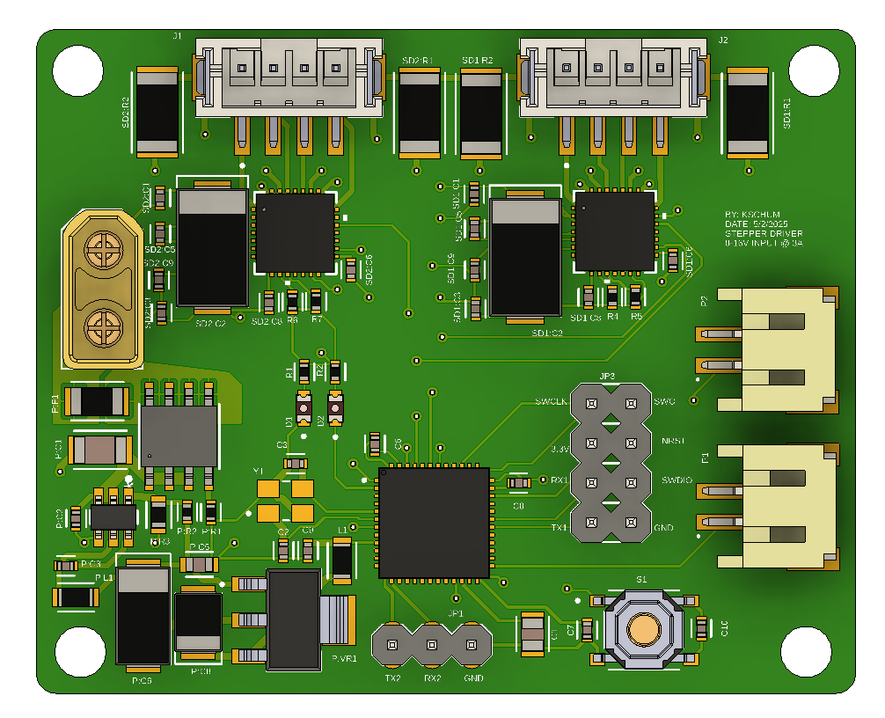

The board now uses 2x silent stepper drivers, along with the respective circuitry to drive it. It will drive 2x 1.5A NEMA 17 stepper motors. There is a 3 pin Dupont connection to connect to a raspberry pi. There are 2x inputs for limit switches to detect the bounds.

**Mechanical Changes**

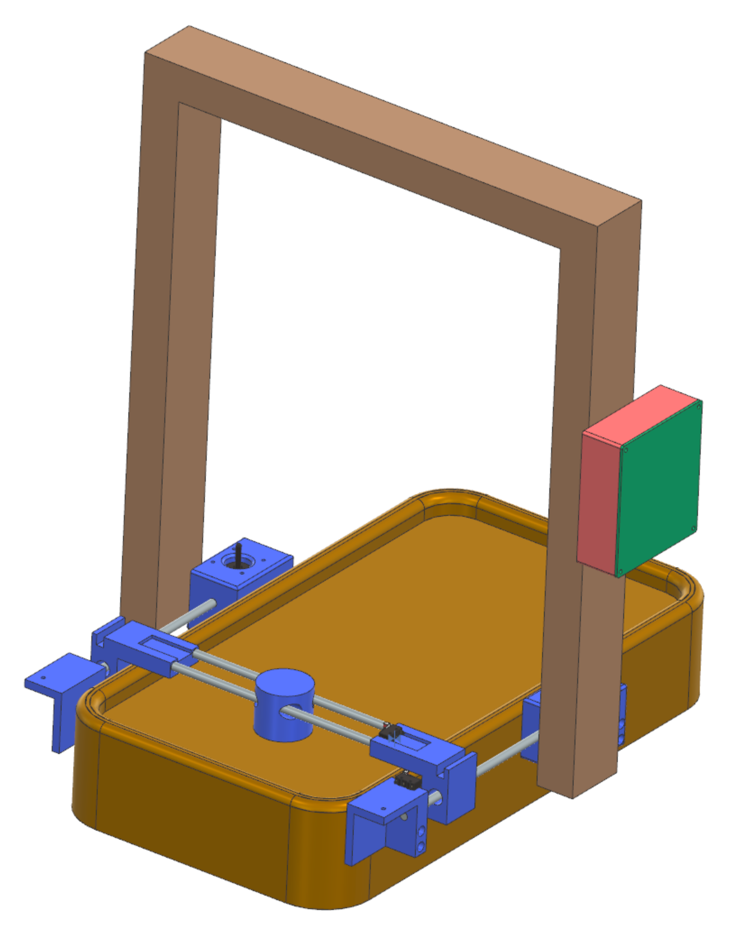

[1] The three stepper motors have been decreased to only 2 to act as a differential. This takes off a heavy stepper from the gantry and should make it faster.

[2] Limit switches added

[3] Camera up above on 2x4’s for full visibility. The height was set by the FOV of the Raspberry Pi camera.

[4] An electronics box was added to the side to mount the custom board and the raspberry pi.

**High Level Wiring Diagram**

